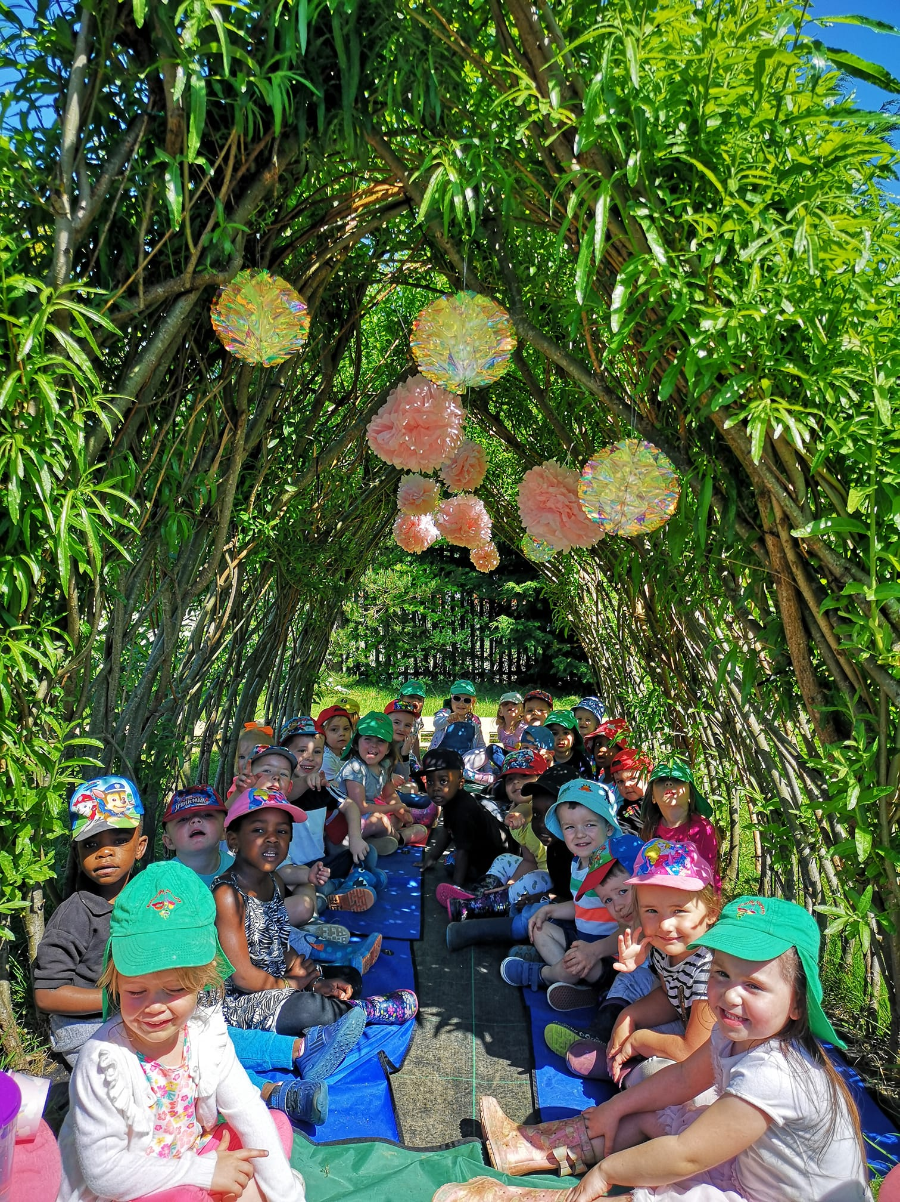
Butterfly Nursery

34 Kilmuir Road, Arden, GLASGOW G46 8BQ
TEL: 0141 638 8597 MOBILE: 07927253346
Registration Number: CS2015341171

WEBSITE: www.butterflynursery.org FACEBOOK: Butterfly Nursery Scotland

Butterfly Nursery Scotland
Child Protection Policy
“It’s everyone’s job to make sure I’m alright” (Child Protection Audit and Review Nov.2002)
Should any member of staff have concerns regarding the welfare and safety of any child they have a duty of care to report these concerns to the Head of Establishment/Depute. He/she, after judging that there may be grounds for concern regarding the welfare or safety of any child must then immediately advise the duty Senior Social Worker at the local Social Work Services;
Phone: 0141 287 0556
Fax: 0141 276 1201
Email: scdchildrenandfamilies@glasgow.gov.uk
If necessary the concerns may have to be referred to the Police by calling;
- 101/999
- Pollok, 37 Brockburn Road, G53 5BG. Tel: 0141 532 5600
The referral can be made by either the Head/Depute or the staff member raising the concern.
The referral will:
- be supported with ‘Notification of Concerns About a Child to Social Work Services’ documentation
- be recorded accurately in our ‘Care and Welfare Chronologies’ which are located in the confidential files
- be submitted as a notification to the Care Inspectorate

To ensure best practice:
Staff – Are briefed about this policy at their induction and receive annual training CP Co-ordinator- Attends specific Child Protection training provided by Glasgow City Council bi-annually Parents/Carers- Receive a copy of this procedure at their child’s induction and further information is on Public Display Children-Are confident and comfortable in our care which reflects both GIRFEC and the Children’s Charter

The Statutory Guidance for Early Learning and Childcare is available in our Policy Folder or at:
National guidance for child protection in Scotland 2021 - gov.scot (www.gov.scot)
Further Information and guidance from ‘The Children and Young People (Scotland) Act 2014 can be found at:
http://www.legislation.gov.uk/asp/2014/8/pdfs/asp_20140008_en.pdf

Butterfly Nursery Scotland
Promoting Positive Behaviour Policy

Statement of Purpose
The Early Learning and Childcare (ELC) setting acknowledges that in working with very young children we play an important role in fostering positive and caring attitudes towards others. We recognise that for the very young child their own personal needs are central and that they are in the process of learning to control their emotions, develop their sharing and turn taking skills and build their concern and empathy for others. We want to foster attitudes that enable them to contribute positively to shared experiences.
In order to support children to do this our focus will be on promoting positive behaviour, endeavouring at all times to take a positive rather than negative approach. Our aim is to be supportive and non-confrontational.
Throughout this policy the term parents is used to include all main caregivers.
Consistency of Approach
In promoting positive behaviour consistency of approach within the staff team is vital to ensure clear messages and avoid confusion for the children. We recognise also the importance of working co-operatively with parents in this area and will share this policy with them and take cognisance of their comments and suggestions.
Staff will at all times present a good role model of behaviour to children, both in their interactions with other adults and with the children themselves.
We will highlight and focus on good behaviour rather than reprimanding children where possible. We will always endeavour to diffuse any potential situation and not escalate it by being confrontational.
Rewards for good behaviour should take the form of praise and adult attention.

Expectations
We expect adults/staff and children to treat each other and the environment with respect, care and concern at all times and will promote this ethos throughout the setting. We will use group, gather and snack times to engage children in non-threatening discussions about appropriate behaviour, acceptable boundaries and why we need guidelines for behaviour within the setting. We will encourage empathy for the feelings and safety of others. Apologies for any lapses in behaviour will be encouraged but never forced.
Positive behaviour expectations of children will also be shared with parents at enrolment and revisited at parents' evenings or consultations to foster a co-operative and consistent approach.

Strategies
The management of behaviour is the responsibility of everyone in the setting and staff, children and parents should work together to develop and establish an approach relevant to all. Positive behaviour will be reinforced with praise and encouragement and staff will set a positive example to children thus enabling a culture of respect to be developed between children and staff. Staff and children will value each other and behave in a tolerant friendly way to each other. To help develop a positive image and acquire discipline, self-monitoring of behaviour should be established. Staff will work as a team and develop a consistent approach when dealing with behaviour. Staff will remain calm and avoid raising their voice.
Conflicts between children should try to be resolved by discussion and negotiation. Children should be given the opportunity to explain the reasons for their behaviour and this should be discussed with the child and reasons explained as to why the behaviour is inappropriate. Children should be made aware of the impact of their behaviour on themselves and others. If the behaviour persists the child should be removed from the situation and moved to another area/quiet space. Limited use should be made of this strategy and it should always be for the minimum amount of time necessary. The child should have the opportunity to make amends for their behaviour and be able to rejoin the group or activity.
Any concerns regarding a child’s behaviour will be discussed, at the earliest opportunity, with the parent to help to try to identify the cause and to share strategies to deal with the behaviour. However the default position will be to deal with behavioural issues within the setting wherever possible.
Toddler’s behaviour can sometimes be difficult to understand but it should be recognised that it is quite normal behaviour for children at this stage of their development. Refusing to eat, resisting bedtimes, not co-operating with toilet training, crying when parents leave the room, temper tantrums, biting, and other forms of seemingly anti-social behaviour are all normal. They are exploring their expanding world and learning to be independent.

Long Term Behavioural Issues
Children may come to the setting who need more focused support to help develop positive behaviour. Staff will have to respond sensitively to the child and positive strategies should be developed and implemented consistently by the staff team. Children may display negative behaviour due to short term circumstances (e.g. family issues) or long term circumstances (e.g. diagnosed conditions such as ADHD). Staff should make every effort to understand why the child is behaving in this way and the parent should be consulted to help identify any reasons for the behaviour. Strategies to help with the behaviour will be shared with the parent and any other relevant professionals in order to identify the best way to support the child. Management will ensure that any child with diagnosed behavioural issues has the relevant support in place and that staff, parents and other professionals adopt a collective and consistent approach to support the child. There should be a shared vision which is understood and followed by all.

Involving Parents
Parents are the prime educators of their child therefore it is important that effective partnerships with parents are established. The setting must ensure that these partnerships are built on trust and mutual respect to help develop positive dialogue between the setting and the home. Sharing ideas and strategies to deal with behaviour ensures a joint approach and leads to an understanding of the needs of the child.

Monitoring of this Policy
It will be the responsibility of the Head of Centre to ensure that all staff, including new or temporary staff, are familiar with this policy and to monitor that it is being implemented. This will be achieved by observing and monitoring practice within the setting and reviewing the policy annually in conjunction with parents and children.

BUTTERFLY NURSERY SCOTLAND
POLICY FOR COLLECTION OF CHILDREN
Rationale:
To implement and embed a co-ordinated and agreed team approach for the safe collection of children from the Nursery.
Aims:
In Butterfly Nursery we aim to:
- Ensure the safe collection of child/ren from our Nursery
- Encourage parents/carers to arrive punctually to collect their child/ren at the end of a session
Objectives:
We will achieve our aims with a staff team approach by:
- ensuring staff are familiar and aware of all individuals who collect children from the Nursery
- maintain good communication between the staff team in respect of changes to normal collection arrangements
- following proper procedures when you are in doubt of identification of collector
Guidelines:
Staff will ensure that:
- Upon enrolment the parent is asked to confirm information provided on their application form, this indicates:
Parent’s details
Emergency contact
Persons authorised to collect
- Authorised collectors are 16 years of age or over
- These records are kept up to date in the child’s file
- In cases of emergency/unforeseen circumstances, an additional person may be nominated by the parent/guardian only to collect the child/ren.
- If this person is unknown to staff, they should be issued with a password as well as confirming their identity upon arrival.
- Parents/carers are encouraged to bring and collect their child/ren on time to instil a consistent and co-ordinated routine
The nursery will not;
- Release the child to anyone who is not authorized to collect.
- Prevent a parent from collecting the child if they are listed on their application unless there is a court order in place. If there is conflict the nursery cannot be involved and would only immediately advise the parent that the child had been collected
- Tolerate any inappropriate behavior and the parent/s would be asked to leave or if necessary, Police Scotland would be contacted.
- If it is considered unsafe for a child/ren to be released into the care of an adult suspected of being under the influence of drink or drugs, another nominated person will be contacted to collect the child/ren
In addition;
- A late charge will be implemented for children not collected within the appropriate timescale (Up to 10 mins £5 and a further £5 for every subsequent 10 mins)
- In the case of a child/ren who have not been collected and if emergency contacts cannot be reached, the Social Work Department will be contacted to ensure the safety of the child/ren.

July 2022

Butterfly Nursery

POLICY FOR ABSENT CHILDREN

Rationale:
“It’s everyone’s job to make sure I’m alright.”
Child Protection Audit & Review 2002

Aims:

To ensure the safety of all the children who are registered with the Nursery. We realise that children can be absent for many reasons, but we believe it is our duty to ensure the safety and well being of these children while they attend the Nursery, and when they are absent.

Objectives:

We aim to do this by:
- recording all absences on the appropriate form
- ensuring all parent/carers are aware of this procedure.
- ask parent/carers to notify us of any absences that they are previously aware of
- ask parent/carers to contact Nursery before 10:00am or 2:30pm (according to session) on the 1st day of absence if their child is sick or unable to attend.
- if no contact has been made by the above times, staff will attempt to contact parents by telephone.
- if contact cannot be made on the 1st day, staff will record this.
- on the 2nd day of absence, if contact has not been made with parents, staff will telephone emergency contact.
- on the 3rd day of absence if no contact has been made with above, staff will telephone all contacts listed on child’s enrolment form and if still no contact can be made Social Services will be notified by the end of the 3rd day.

* Please note that the above steps will be used as normal procedure for the protection of all our children.

If a child or one of their family members need to isolate or have tested positive, they must send a copy of their track and trace message/email to the head of centre and isolate for required number of days


Lending Library

On a Wednesday your child will choose a book from the Lending Library. We would ask that, if possible, you or another family member spend a short period of time each day to read the story to your child.
Looking at pictures and print develops an interest in stories and literacy which plays a vital role in their future learning, and helps to develop their:
- listening skills
- concentration
- language and vocabulary
- Understanding of the link between written & spoken word
- Sequencing concept
Preparing for a story
- Find a comfortable place that is free from distraction
- Sit alongside child and look at the book together
- Teach your child how to handle book properly, turn the pages, reading from left to right
- Use expression in your voice
- Encourage your child to participate; talk about pictures
- Ask them questions after reading the story

Remember, children often enjoy reading the same story over and over again
Butterfly Nursery

Fee Collection and Payment Policy and Guidelines

Rationale
To provide high quality, affordable childcare and education. The nursery is a registered charity within the voluntary sector and we work in partnership with Glasgow City Council.

Aims
Fees are necessary to develop and sustain the service, therefore, when a child starts, the basis on which fees are paid will be made clear to the parents/carers of the child and are as follows:
- The amount they will be expected to pay
- When/how often fees will be collected
- Payments in the case of absence due to holidays or sickness
- Parents/carers are required to sign a fee contract acknowledging that they have read and understood the terms and conditions

Objectives
When collecting fees the group will at all times treat all parents/carers who use the service with respect and confidentiality.

Fees Review
In Committee/Board run groups it is the responsibility of the group’s membership to decide on the level of
fees to be charged. The Board of Directors will propose the fee level to the membership.
All fees paid are solely for the use of the service and will be used to pay for staff salaries, operational costs and equipment to develop and sustain the service.
The Board of Directors will inform parents/carers of any proposed changes to fees prior to their implementation, thus providing an opportunity to discuss levels before deciding on the proposal. Generally, if there is an increase in fees, the increase will come into effect from the start of the new term.

Payment Dates/Method
Fees are required to be paid in advance, at least by the Monday of the commencing week. This can be either, weekly, fortnightly, or monthly in advance by bank transfer or standing order (Cash will be accepted although not advised). Parents and carers of children using the group will be made aware of the system when joining the group to ensure that payment is made on time.

*Children will not be able to access the service if the fee for the coming week has not been paid.

Payment details

Royal Bank of Scotland
Butterfly Nursery Scotland
Account Number: 10946553
Sort Code: 83-20-22

Please ensure child’s name is used as reference in order for us to identify payment.

Payment whilst not using the service
Payment for the service is required at all times, including whilst being on holiday and absence. You are technically buying/securing your child’s placement for the whole year as per fee contract agreement.

Additional Information Section

Working Families Tax Credits
Working Families Tax Credit can help with your childcare costs, please speak to the relevant agencies/professionals regarding further information on the application process. Please note, although payment of tax credits is in arrears, payment for the use of the service must be paid in advance, therefore confirmation from such agencies must be provided before placement can commence.

Refund Entitlement
Any overpayment of fees will be repaid in full.
If, in the event that it is not possible to provide the service for any reason e.g. building
closure, adverse weather conditions causing staff to be absent etc, the Board would consider whether a refund for fees is appropriate or not and decide the most appropriate and fair action for their group.
If the decision taken provides for a refund, consideration should be given to whether users may be entitled to a full or a partial refund of fees after an agreed number days and for each session the child attends thereafter until the service can be resumed.

Recovery of Debt
If fees are not paid, the other alternatives for recovery will be to pass the debt to a debt collection
agency and/or the small claims court. The costs of these processes will be added to the outstanding
debt.

